

Deploy Solar in Docker Container
V1.0
Jan, 2018

Table of Contents

What is docker and its purpose 2
Docker 2
Purpose 2
Installation and uninstallation of docker on ubuntu 3
Installation of Docker 3
OS requirements to install Docker CE: 3
Set up the repository 3
Install Docker CE 4
Uninstall Docker 5
DockerFile and its usage 5
Running multiple processes using docker 6
Creation of an Image in docker 6
Docker Image 6
Building a docker image 7
Deploy/run the docker container 7
Start and stop docker Containers 7
Start Docker 7
Stop Docker 7
Remove image from docker container 8
Setup MySQL Docker container 8
Deployment of Solar application in docker container 10

What is docker and its purpose

Docker
Docker is a tool designed to make it easier to create, deploy, and run applications by using containers. Containers allow a developer to package up an application with all of the parts it needs, such as libraries and other dependencies, and ship it all out as one package. By doing so, the applications will run on any other Linux machine regardless of any customized settings that machine might have that could differ from the machine used for writing and testing the code.
Docker is a bit like a virtual machine. But unlike a virtual machine, rather than creating a whole virtual operating system, Docker allows applications to use the same Linux kernel as the system that they're running on and only requires applications be shipped with things not already running on the host computer. This gives a significant performance boost and reduces the size of the application.

Purpose
Docker is a tool that is designed to benefit both developers and system administrators, making it a part of many DevOps (developers + operations) toolchains. For developers, it means that they can focus on writing code without worrying about the system that it will ultimately be running on. It also allows them to get a head start by using one of thousands of programs already designed to run in a Docker container as a part of their application. For operations staff, Docker gives flexibility and potentially reduces the number of systems needed because of its small footprint and lower overhead.

Installation and uninstallation of docker on ubuntu

Installation of Docker
Docker is available in two editions.
- Community Edition (CE)
- Enterprise Edition (EE)
Docker Community Edition (CE) is ideal for developers and small teams looking to get started with Docker and experimenting with container-based apps. Docker CE has two update channels, they are Stable and Edge
- Stable gives you reliable updates every quarter
- Edge gives you new features every month
Docker Enterprise Edition (EE) is designed for enterprise development and IT teams who build, ship, and run business critical applications in production at scale

OS requirements to install Docker CE:
To install Docker CE, we need the 64-bit version of one of these Ubuntu versions:
- Artful 17.10 (Docker CE 17.11 Edge and higher only)
- Zesty 17.04
- Xenial 16.04 (LTS)
- Trusty 14.04 (LTS)
Before you install Docker CE for the first time on a new host machine, you need to set up the Docker repository. Afterward, you can install and update Docker from the repository.

Set up the repository
Step 1 : Update the apt package index:
$ sudo apt-get update

Step 2: Install packages to allow apt to use a repository over HTTPS:
$ sudo apt-get install \
apt-transport-https \
ca-certificates \
curl \
software-properties-common

Step 3: Add Docker’s official GPG key:
$ curl -fsSL https://download.docker.com/linux/ubuntu/gpg | sudo apt-key add –
$ sudo apt-key fingerprint 0EBFCD88
Step 4: Use the following command to set up the stable repository. You always need the stable repository, even if you want to install builds from the edge or test repositories as well. To add the edge or test repository, add the word edge or test (or both) after the word stable in the commands below.
Note: The lsb_release -cs sub-command below returns the name of your Ubuntu distribution, such as xenial.
$ sudo add-apt-repository \
"deb [arch=amd64] https://download.docker.com/linux/ubuntu \
$(lsb_release -cs) \
stable"

Install Docker CE
Step1: Update the apt package index.
$ sudo apt-get update

Step 2: Install the latest version of Docker CE, or go to the next step to install a specific version. Any existing installation of Docker is replaced.
$ sudo apt-get install docker-ce

Step 3: Docker is installed successfully. To test whether docker is running or not, use the following command
$ sudo systemctl docker status

Uninstall Docker
Step1: Uninstall the Docker CE package
sudo apt-get purge docker-ce

Step2: Images, containers, volumes, or customized configuration files on your host are not automatically removed. To delete all images, containers, and volumes:
$ sudo rm -rf /var/lib/docker
You must delete any edited configuration files manually.

DockerFile and its usage

Each Dockerfile is a script, composed of various commands (instructions) and arguments listed successively to automatically perform actions on a base image in order to create (or form) a new one. They are used for organizing things and greatly help with deployments by simplifying the process start-to-finish.
Dockerfiles begin with defining an image FROM which the build process starts. Followed by various other methods, commands and arguments (or conditions), in return, provide a new image which is to be used for creating docker containers.
Ex: FROM fedora
RUN yum
install -y mongodb-server && mkdir -p /data/db
EXPOSE 27017
VOLUME ["/data/db"]
CMD mongod
Explanation: We're building on the 'fedora' image, running a shell command to install software and make directory, then declaring a port to publish, and directory to store in. Finally, we're declaring the command to be executed for this container's runtime

Running multiple processes using docker

Generally a Docker container starts with a single process when it is launched, for example an Apache daemon or a SSH server daemon. Often though you want to run more than one process in a container. There are a number of ways you can achieve this ranging from using a simple Bash script as the value of your container’s CMD instruction to installing a process management tool.

Creation of an Image in docker

Docker Image
A Docker Image is the template (i.e application plus required binaries and libraries) needed to build a running Docker Container (the running instance of that image).
As templates, images are what can be used to share a containerized applications. Collections of images are stored/shared in registries like Docker Hub. When a you download an image, it can then be used (as a template) to spin up multiple running Containers in your own environment.
Docker can build images automatically by reading the instructions from a Dockerfile, a text file that contains all the commands, in order, needed to build a given image.

Building a docker image

The docker build command builds Docker images from a Dockerfile and a “context”. A build’s context is the set of files located in the specified PATH or URL. The build process can refer to any of the files in the context. For example, your build can use a COPY instruction to reference a file in the context.
$ docker build -t <ImageName>

Deploy/run the docker container

A docker image is a separate file system so here you have a different /bin/ls or /bin/date etc. When this image is instantiated it's name is a container. So a container is a running image and this running image's kernel is also just the main host kernel and uses some kernel features to isolate stuff such as processes, network, mount points. The host OS can see through into the container though but not vice versa.
$ docker run -d --name <ImageName> -p 8080:8080 -p 28080:28080 -t <ImageName>

Start and stop docker Containers

Start Docker
$ docker start <ImageName>
Ex: $ docker start solar

Stop Docker
$ docker stop <ImageName>
Ex: $ docker stop solar

Remove image from docker container

Use the docker images command with the -a flag to locate the ID of the images you want to remove. This will show you every image, including intermediate image layers. When you've located the images you want to delete, you can pass their ID or tag to docker rmi
Step 1: Check whether the image is running by using following command
$ docker ps -a
Step 2: If the image is running then use the following
$ docker stop <ImageName>
$ docker rm <ImageName>
Step 3: Remove the image files
$ docker rmi <ImageName>

Setup MySQL Docker container

Step1: Create ‘mysql’ directory and copy the solar database into it
$ mkdir mysql
$ copy /media/sf_newbuild/mysql-docker/solar.sql mysql/
Step2: Write a docker file script to create docker image for solar mysql database
FROM mysql:5.7
# Environment variables
ENV MYSQL_ROOT_PASSWORD=root
ENV MYSQL_DATABASE=solar
ENV MYSQL_USER=solar
ENV MYSQL_PASSWORD=solar

COPY Solar.sql /docker-entrypoint-initdb.d/

Step 4: Build the docker image based on dockerfile
$ docker build –t mysql

Step 5 : Run the container
$ docker run –d –name –p 3306:3306 –t mysql

Step 6: Go to the mysql container
$ docker exec –it mysql bash

Step 7: Connect to mysql database in the container for any changes
$ mysql –u solar –p solar
$ use solar;

Deployment of Solar application in docker container

Step1: Create ‘solar’ directory and copy the related jar files into it
$ mkdir solar
$ copy /media/sf_newbuild/11thJan/jarfiles/* solar/
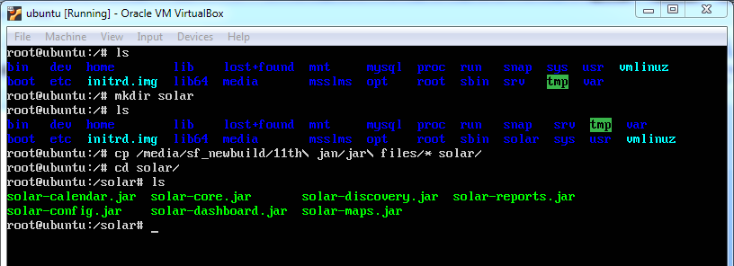

Step2: Write a docker file script to create docker image for solar (Copying the dockerfile which is already created for solar)
$ copy /media/sf_newbuild/Dockerfile solar/
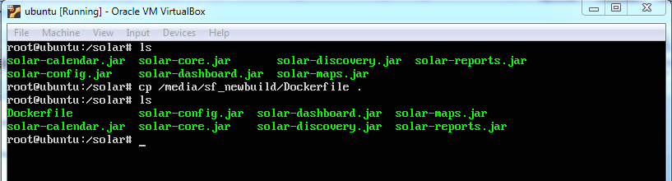

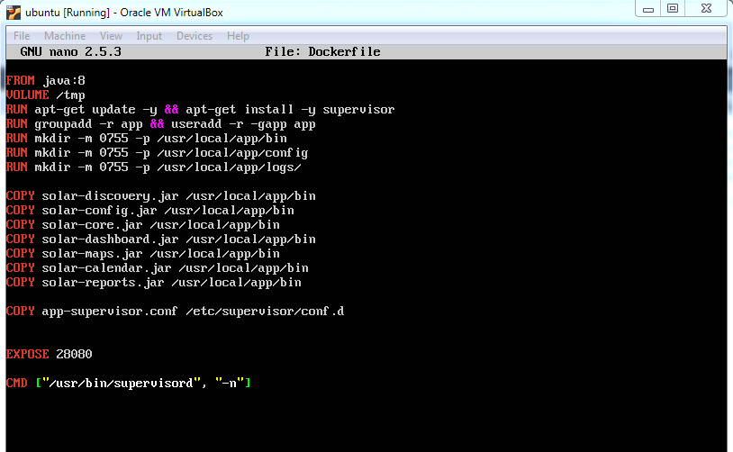

Step 3: Copy the app-supervisord.conf file
$ copy /media/sf_newbuild/app-supervisord.conf solar/
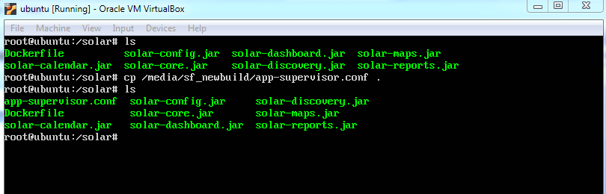
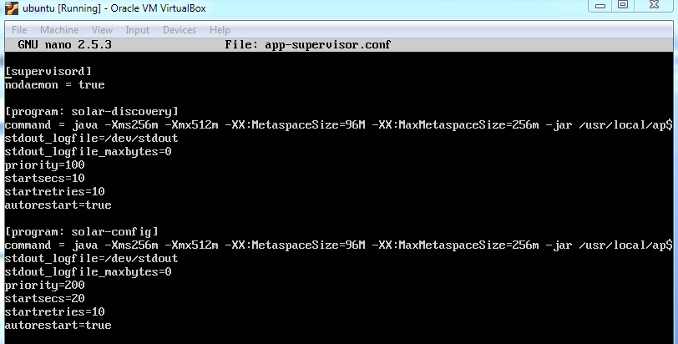

Step 4: Build the docker image based on dockerfile
$ docker build –t solar
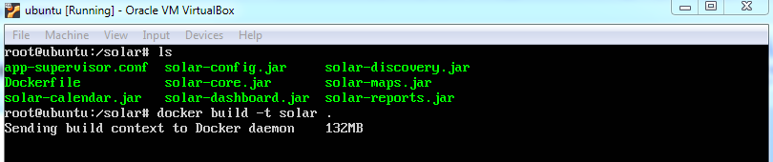
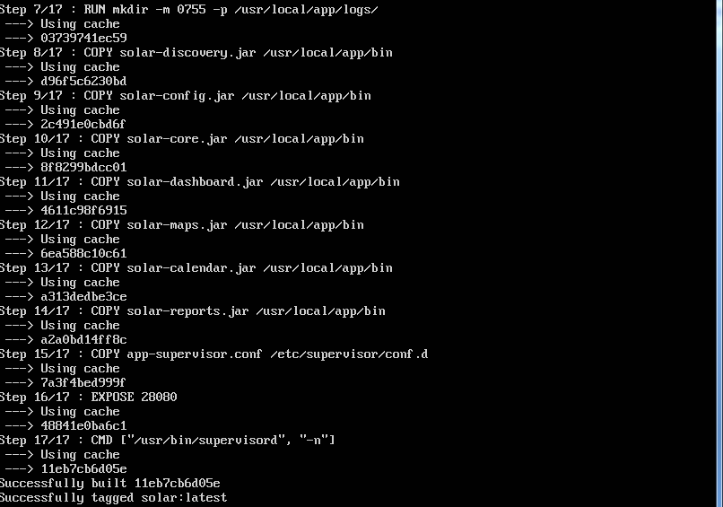
Step 5 : Run the container
$ docker run –d –name –p 8080:8080 –t solar
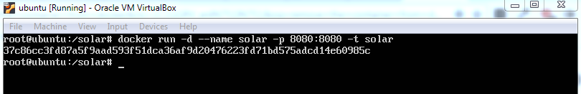

Step 6: Go to the solar container
$ docker exec –it solar bash
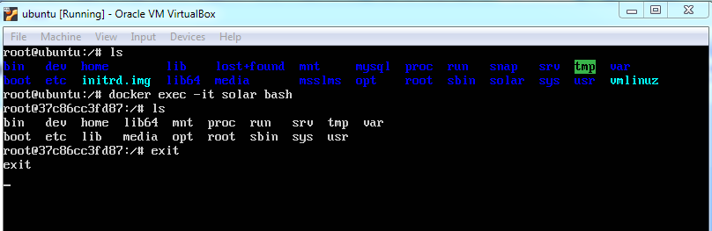

Step7: Check the application in the browser with ip address and the port number http://192.168.3.34:8080/

